Present Tense
Basics

Statement:
- In der Gegenwart (Present Tense) wird das Verb für I/you/we/you/they gleich gebildet.
- Wenn du über eine Person, ein Tier oder ein Ding sprichst (he/she/it), dann musst du ein -s anhängen.
 | Person (singular) | Verb |  | Person  (plural) | Verb
1 | I | live here.  like apples.  speak English. | 1 | we | live here.  like apples.  speak English.
2 | you | live here.  like apples.  speak English. | 2 | you | live here.  like apples.  speak English.
3 | he / she / it | lives here.  likes apples.  speaks English. | 3 | they | live here.  like apples.  speak English.

!
he/she/it – das -s muss mit!

- Wenn das Verb auf ein -o oder einen Zischlaut (-ch, -sh) endet, dann wird -es angehängt:

I go to school. -> My brother ………….…….. to school.
They catch the ball. -> My sister …………….….. the ball.
You wash your hair on Mondays. -> She ………….…….. her hair on Tuesdays.

- Wenn das Verb auf einen Konsonanten und ein -y endet, dann wird das y zu -ie:

We carry the bag. -> He ………….…….. the bag.
Aber: I play football -> She plays football.
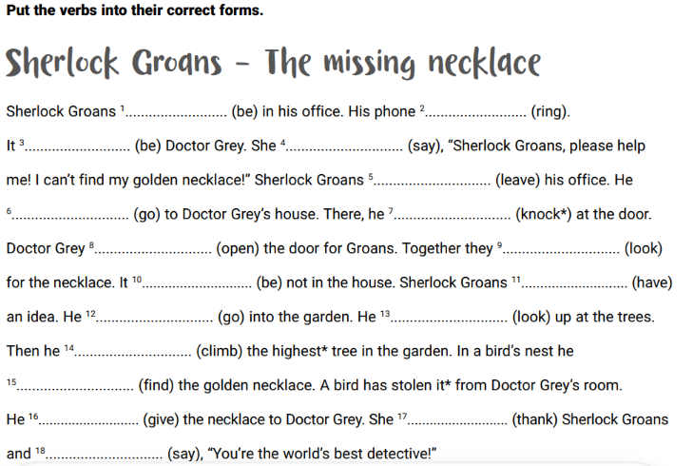

Negation:
- Für die Negativ-Form muss do/does zur Hilfe genommen werden.
 | Person (singular) | Verb |  | Person  (plural) | Verb
1 | I | don’t live here. | 1 | we | don’t live here.
2 | you | don’t live here. | 2 | you | don’t live here.
3 | he / she / it | doesn’t live here. | 3 | they | don’t live here.

Exercise:
Fill in the correct form of the verb.

- Patricia _________ (like) the story.
- Martha ___________________ (not, live) her. She _____________ in England.
- My best friend only _____________ (speak) English, because she lives in London.
- Our new neighbour ____________ (not, like) animals.
- I ______________(not, speak) any Italian, but I ____________ German and English.
- You __________________ (not, like) bananas, do you?
- Me and my sister ___________ (like) pineapples on a pizza, but many people ______________ (not, like) them.
- My parents and I _____________ (live) in Salzburg, Austria.
- The dog ____________ (like) playing in the garden.
- I have a good friend in the USA. She _________________ (not, speak) any German.

